ELECTRIC SCOOTER
User’s Manual

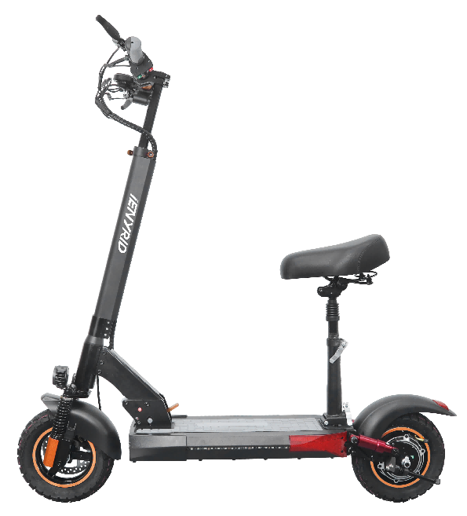

We are glad introduce to you our new product.
When we developing this product, we were inspired by the world outlook that the vehicle shall be easy to use in everywhere and accessible to everyone.
During three-year work, we paid special attention to details, in order to make driving more comfortable, and the folding and unfolding process simpler.
We hope the electric scooter will become an integral part of your life.
Hope you enjoy the journey and drive safely!

Main Parts

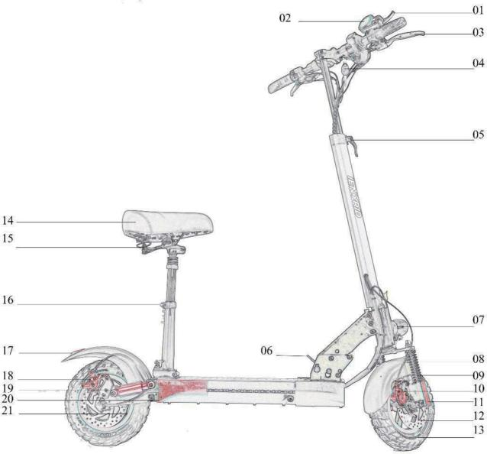

01: Accelerator
02: Meter
03: Rear Brake Control Bar 04: Key of Electric Lock 05: Height Adjust Lock
06: Folding Plug
07: Headlight with Horn 08: Front Fender
09: Front Dampers 10: Front Disc Brake 11: Reflective Stickers
12: Front Disc Plate 13: Front Tire
14: Seat Bag
15: Seat Bag Folding Plug 16: Seat Height Adjust Lock 17: Taillight
18: Rear Disc Brake 19: Rear Dampers
20: Side Lights
21: Hall Motor

Assembly the Electric Scooter

Products' List

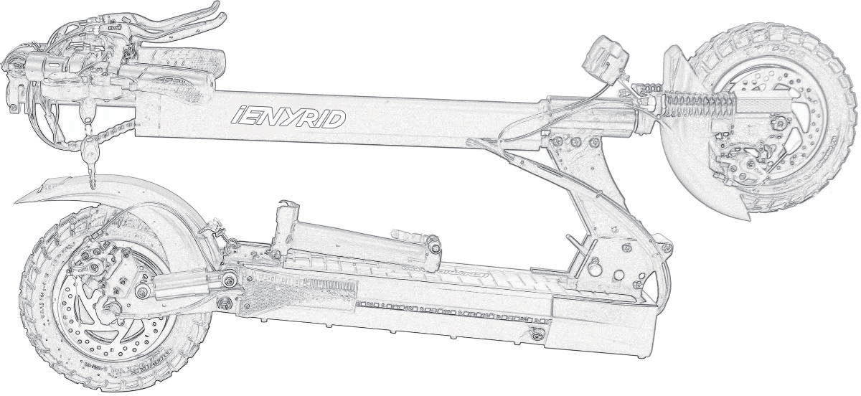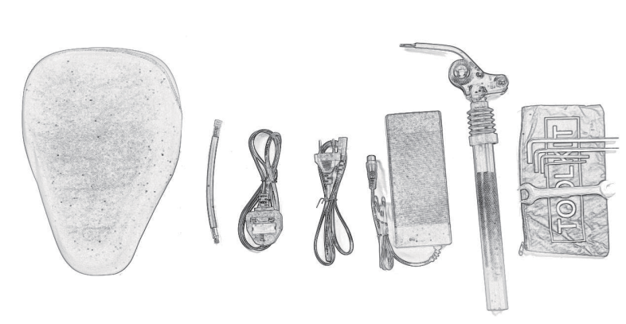1/ Electric Scooter 2/ Seat Bag
3/ Valve Extension Cable 4/ UK Charging Plug
5/ EU Charging Plug 6/ 110-240V Adopter 7/ Seat Support Rod 8/ Simple Tools

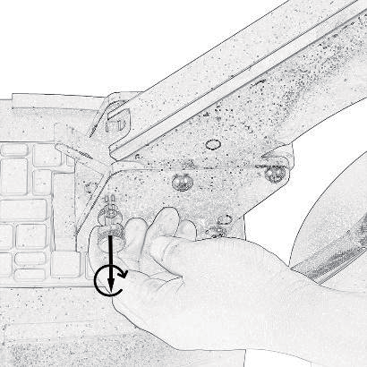
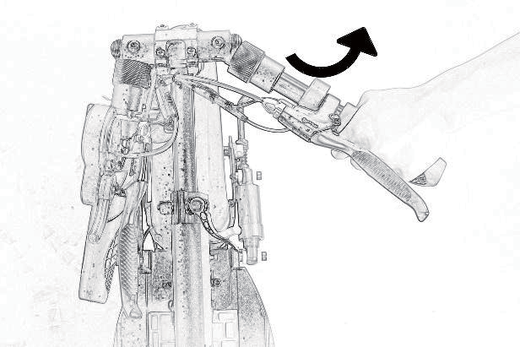
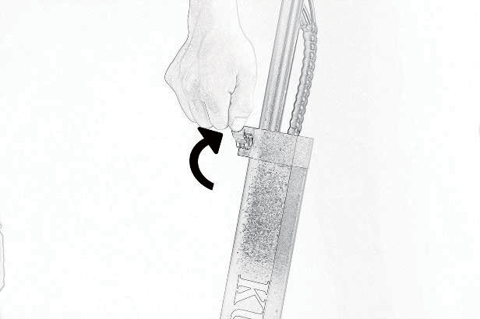
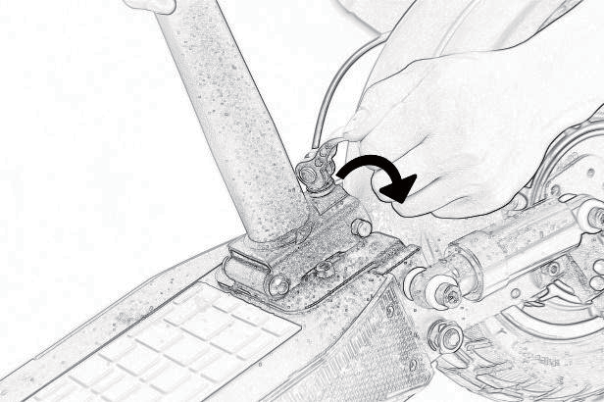
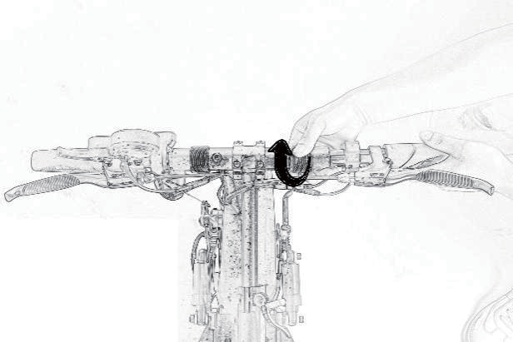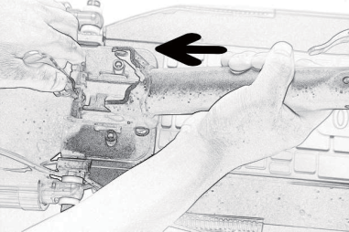Expend the Electric Scooter

- Replace the seat
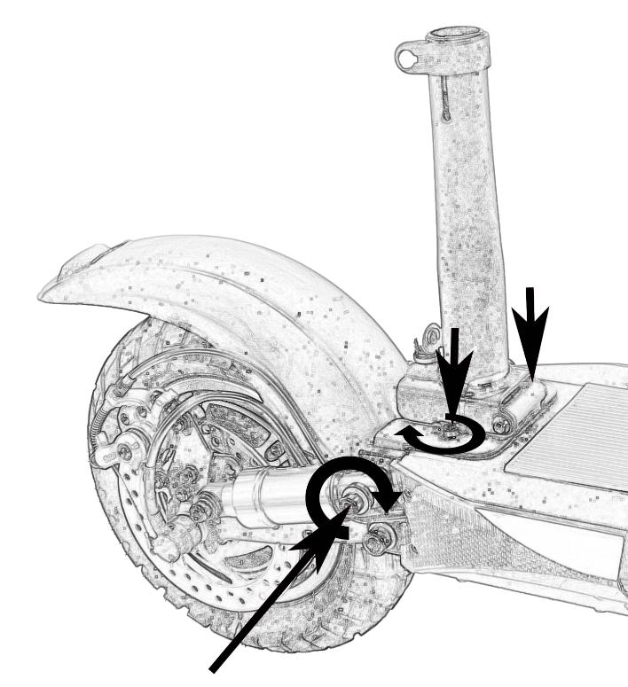
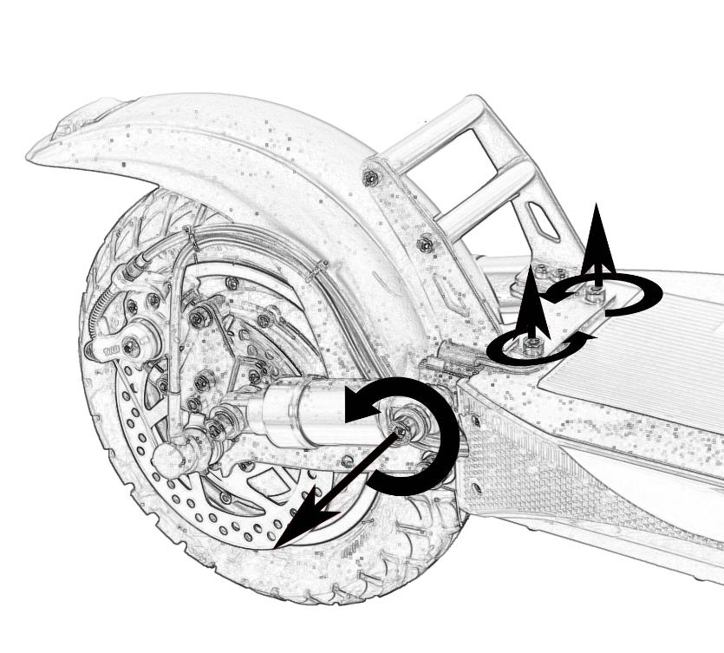

- Checking the Function of the Scooter

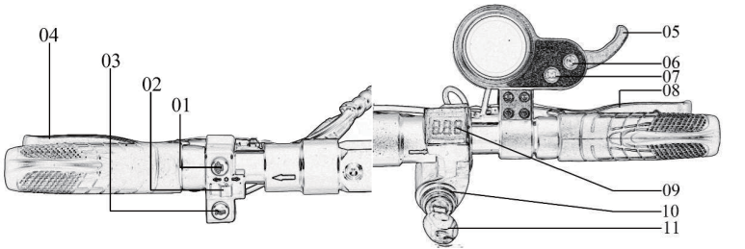01: Driving Light Switch 02: Turning Light Switch 03: Horn Switch
04: Rear Brake Controler Bar 05: Accelerator
06: Meter Power Button
07: Model Button
08: Front Brake Controler Bar 09: Volt Display
10: Power Lock
11: Power Lock Key

Control before Operating
- Checking the start of the accelerator and steering wheel. Turning the power off, pull the throttle lever a few times. Make sure it returns to its original position. Please do not pull the trigger, work smoothly.
- Checking brakes and cables. Check the braking power. If the braking system is weak, please adjust before use. If the brake is jammed or there is an unusual noise, check the inner brake cable of wear and deformation.
- Check tire pressure and condition. Check the front and rear tires whether there is puncture and tread wear. Make sure the tire pressure is at the recommended level: 23 kg per SQCM. Replace tires by wear degree (damage, tread wear, etc.).
- Checking the folding part and the steering wheel. Folding/Unfolding: make sure the folding lock lever is locked and in the upright position. Make sure the stand is folding smoothly.
- General condition check: Some parts of the electric scooter require regular maintenance check: chassis fork, tires, bearing, cable, other parts.

Safety
Follow our operating tips to avoid unwanted damage and consequences.

Recommendations
- Make sure that driving an electric scooter does not contradict local traffic rules.
- Avoid driving in poor visibility.
- Do not perform various tricks on an electric scooter.
- Do not perform various tricks on an electric scooter.
- Strictly not recommend driving while intoxicated
The manufacturer is not responsible for breakdowns due to improper use of the electric scooter.

Why do you need an instruction manual?

The manual allows you to learn the features of the electric scooter better to enjoy driving fully. When driving for the first time, be extremely careful on the road. Do not connect the charger if the charging port is damaged or the battery is already fully charged.

Battery and Charger

Battery

DO NOT turn on the engine while recharging.
The charge indicator shows only two stages (discharged / charged).
Do not leave a fully charged battery for a long time (more than two months). The battery can be discharged while driving, braking, the headlight on.

DO NOT use the battery:
- If the battery is damaged.
- If the battery heats up or is deformed.
- If the battery leaks.

if the battery leaks, in any case do not contact with it.
the battery must not be accessible to children and animals.
A faulty battery can be explosive and cause irreparable damage to health. Charge the battery in designated and equipped areas.

Recharging
The battery of the electric scooter is designed for multiple recharging. Insert the charging cable into the battery port located on the front right under the deck, then connect the cable to the network.
During charging, the indicator lights up in red.
The indicator will turn green when the battery is fully charged. Do not use the already used or third-party batteries.
For long periods of downtime, it is recommended to charge the battery at least once a month for 9 hours, after each trip it can take up to 12 hours to recharge.
Before installing, repairing or removing the battery, MAKE SURE that the electric scooter is unplugged. Otherwise, it can lead to a short circuit and completely the electric scooter will out of operation.

DO NOT use disparate objects and equipment of other manufacturers not specified in construction for recharging; this may result in the ignition or leakage of toxic elements from the battery. USE only equipment supplied with the electric scooter.

Display
Driv

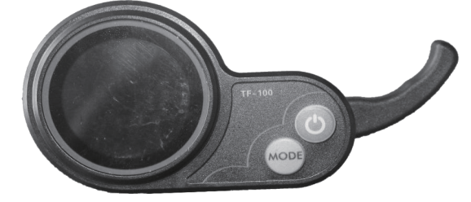

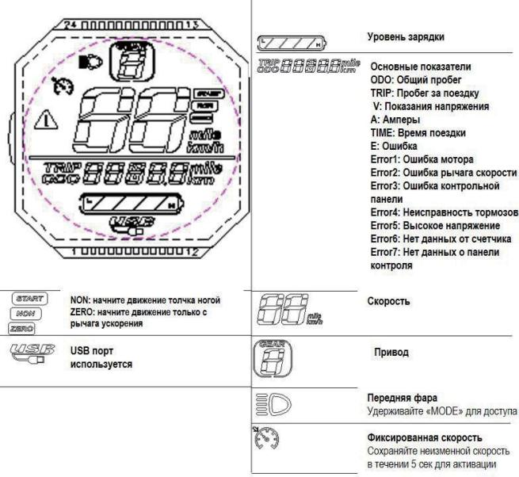
Charging Level
Basic Signs:
ODO: total mileage TRIP: Riding mileage V：Pressure signal TIME: Riding Time Error1: Engine error Error2: Speed lever error
Error3: Control panel error Error4: Brake Mistake Error5: High Pressure Error6: No data on counter
Error7: NO data on control panel
Speed
e Unit
Headlight
Hold on <MODE> for access
Fixed Speed
Keep unchangeable speed in 5 second for activation

USB port

NON: Start to move by feet
ZERO: Start to move only by speed

Recommendations

- Recommended tire pressure:
Make sure the tire pressure is at the recommended level: 20-25 kg per SQCM.

Recommended equipment: helmet
Highly recommend you wear a safety helmet when driving an electric scooter, as in most driving incidents, major injuries occur on the head. Read the instructions on how to wear a helmet properly before use.

Safety Testing of Mechanical
Before use, visually check whether all the bolts are in place, whether all the parts are in place, if something you concerned, then send the electric samovar for diagnosis. Recommended tire and its pressure: Spin the wheels several times manually, if the rotation of the wheels worries you, send the electric scooter for diagnosis.

Tip:
Lean forward while driving to accelerate, and lean back if you need to slow down.

Safe driving
Control

For safe driving, you should first be very familiar with the product, select a suitable open place for riding. Drive carefully, reduce speed before cornering, and brake slowly when speed decreases.

Start of movement
Put one foot next to the electric scooter; the other foot on the deck closer to the helm. Make sure you stand steadily, then gently push the electric scooter forward with your foot on the ground, just like with an ordinary scooter. Put the other foot on the deck closer to the rear bumper. When the body is leaning forward, press the acceleration button. Start to increase speed.

Start of sitting
Sit on the seat of electric scooter, put one foot on the deck, leave the other on the ground. Gently press the acceleration button, and when the electric scooter begins to move at needed speed, put the second foot on the deck. Start of sitting Turning:
Use the steering wheel to turn, but do not forget to keep your hands parallel to your body, when looking around making sure the maneuver is safe

Braking:
Slowly brake and remember the center of gravity. Recommend to lean back a little when you need to brake.

Grease:
Maintenance

Every 6 months, you should grease the guiding mechanics folding and shock absorbance with silicone. Also, check the bolts; tighten if necessary.
Caution: Do not use rust resistant grease. Do not lubricate the wheel tread. Brake
Check the braking power. If the braking system is weak, please adjust before use. If
the brake is jammed or there is an unusual noise, check the inner brake cable for wear and deformation.

The battery supplied with the equipment can charge at least 800 times. If necessary (mileage loss), replace the battery.

Characteristics

Model:
Body: | Aluminium alloy
Motor: | 48V 500W single stage
Battery: | 48V 16Amp Lithium
Adapter: | Incoming 100-240 V, Outgoing 54.6 V 2A
Brakes: | Mechanical disc brake
Tires: | 80/65-6 Pneumatic dirt tires
Lights: | Front LED headlight, turn signals and taillight
Max. loading: | 150 kg
Max. speed: | 40-45 Km / h
Trip distance: | 30-50 Km without recharging
Charging time: | 6-8 hours
Gradeability: | 10 degrees
Wheelbase: | 85 cm.
Dimensions: | 119.5*26*50.5cm
Product weight: | 23.9 kg

